**ESP32 Developing Timer Parts V1.0 Beta 31/01 2024**

**Note:- This is an early development document. Parts detailed below may be added or changed. It allows those interested to see what is involved and order parts, if they wish, to get a head start on the project.**

Below are links to the parts required to make the ESP32 Developing Timer.

Links are valid now, but of course could become dead in the future.

Links are a guide only. Use a supplier that ships your country.

Ordering from China either from eBay sellers or AliExpress, the parts will be much cheaper.

Note, often if buying from AliExpress, there is a free express shipping option, if buying parts over a set value.

**1. ESP32 Development Board. NodeMcu OR Lolin D32**

Pick ONE of the two development boards below. Either will work. The NodeMcu comes with header pins pre-soldered, but there is no socket for battery backup or charging,  
  
The Lolin D32 requires the header pins soldering, but has the advantage of connection of a backup battery & charging.

**ESP32 NodeMcu board. 38 pin version. USB-C CP2102**

[ESP-WROOM-32 ESP32-S Nodemcu ESP32 Development Board ESP32 Bluetooth Wifi 32Mbit SPI Flash Bluetooth Module ESP32 30 Pin/38Pin - AliExpress](https://www.aliexpress.com/item/1005005917503049.html?spm=a2g0o.productlist.main.21.49c921eaFvkmVO&algo_pvid=911c6c9f-fed6-4702-9d28-aa05553792e4&algo_exp_id=911c6c9f-fed6-4702-9d28-aa05553792e4-10&pdp_npi=4%40dis%21GBP%214.47%212.10%21%21%215.52%212.59%21%40211b815c17056862661375645e9c21%2112000034843028200%21sea%21UK%212089347981%21&curPageLogUid=HBs1XskYUDvG&utparam-url=scene%3Asearch%7Cquery_from%3A)

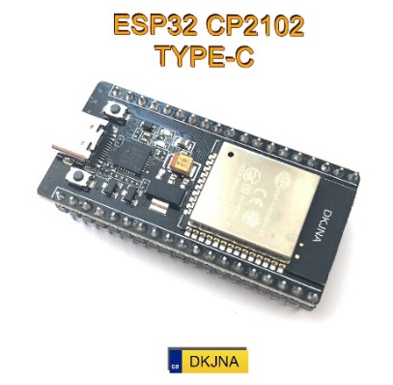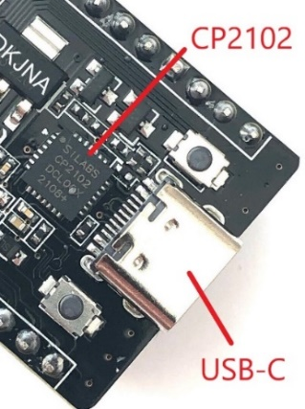

***IMPORTANT. There are multiple variants of this board. Get 38 pin USB-C and CP2102 chip.***Note:- The guides have been written for this specific board type. Boards which differ with their USB chip and/or connector will still work, but the guides will not detail different driver installs or pin layout differences.

**ESP32 Lolin Wemos board**

[For LOLIN D32 V1.0.0 - Wifi+Bluetooth Board Based ESP-32 Esp32 ESP-WROOM-32 4MB FLASH For Arduino MicroPython Compatible - AliExpress](https://www.aliexpress.com/item/1005006407300968.html?spm=a2g0o.productlist.main.11.45b3f7f2ndb8nq&algo_pvid=036cef7b-f73b-4b5f-b963-f0ab78124c70&algo_exp_id=036cef7b-f73b-4b5f-b963-f0ab78124c70-5&pdp_npi=4%40dis%21GBP%218.38%212.43%21%21%2174.00%2121.46%21%40211b61d017071413077041494e9459%2112000037055798254%21sea%21UK%212089347981%21&curPageLogUid=aLMC1Cz1h97C&utparam-url=scene%3Asearch%7Cquery_from%3A)

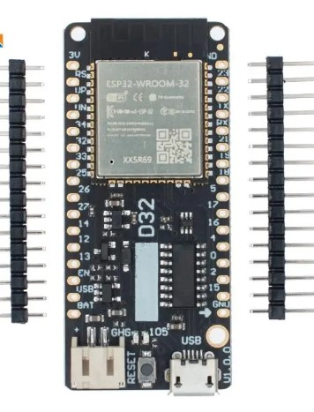

**2. ESP32 prototype/breakout board (38 pin screw-terminal version).**

**Note:- You need this board regardless of the ESP32 board choice. If using the Lolin board, the breakout board legends will not match, so pay attention to the wiring guide.**

[ESP32 Expansion Board Compatible with ESP32 WiFi Bluetooth Development Board NodeMCU-32S Lua 38Pin GPIO Expansion Board - AliExpress](https://www.aliexpress.com/item/1005005677080016.html?spm=a2g0o.productlist.main.1.49c921eaFvkmVO&algo_pvid=911c6c9f-fed6-4702-9d28-aa05553792e4&algo_exp_id=911c6c9f-fed6-4702-9d28-aa05553792e4-0&pdp_npi=4%40dis%21GBP%2110.12%213.32%21%21%2189.95%2129.51%21%40211b815c17056862661375645e9c21%2112000033982834085%21sea%21UK%212089347981%21&curPageLogUid=KAJLsOZrMVRT&utparam-url=scene%3Asearch%7Cquery_from%3A)

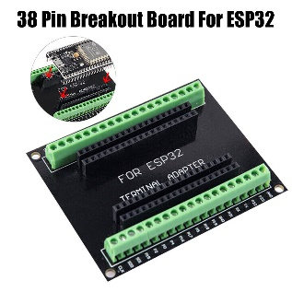

**3. Button Module.**

There are all sorts of buttons available, feel free to choose different ones depending on your final design. This module has the advantage of header pins for use with Dupont jumper wires & is great for development, but the coloured buttons below will be better for the final build.

[DIY Kit 1x4 4 Independent Key Button Keypad Keyboard Module Mcu for Arduino Student Class Design Graduation Project Experiment - AliExpress](https://www.aliexpress.com/item/1005002483504604.html?spm=a2g0o.productlist.main.3.2af42b91tjMlN2&algo_pvid=4b5719b8-15ce-4a47-b74f-141f71825843&algo_exp_id=4b5719b8-15ce-4a47-b74f-141f71825843-1&pdp_npi=4%40dis%21GBP%210.18%210.16%21%21%210.22%210.20%21%402103871e17056849189541323e400e%2112000020816258869%21sea%21UK%212089347981%21&curPageLogUid=PZgEEYQ7WWnf&utparam-url=scene%3Asearch%7Cquery_from%3A)

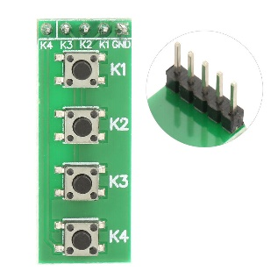

**4. Buttons.**

If mounting in a project box, these buttons are easier to fit and make a nice-looking project. The display will state which colour button to push, Green for the Start Button, Blue for the reset & yellow for the optional motor twiddler.

[DaierTek 5PCS 12mm Momentary Push Button Switch On Off Mini Round Switch Waterproof PBS-33B 3A 125V AC with Pre-soldered Wire - AliExpress](https://www.aliexpress.com/item/1005005789195514.html?spm=a2g0o.productlist.main.31.1abb58c9bntwCj&algo_pvid=8a2910a7-f94d-4836-8e34-bac5274c57e5&algo_exp_id=8a2910a7-f94d-4836-8e34-bac5274c57e5-15&pdp_npi=4%40dis%21GBP%212.28%211.16%21%21%2120.26%2110.33%21%40211b613117070764750182420eefa8%2112000034362500664%21sea%21UK%212089347981%21&curPageLogUid=cjBcGnCD4JhI&utparam-url=scene%3Asearch%7Cquery_from%3A)

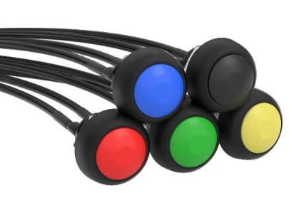

**5. Dupont wires.**

Get male to female Dupont Wires if using the screw terminal prototype board.  
Two packs of 20cm for connection to buttons, tft, encoder etc.

One pack each, 20cm Black wires  
One pack each, 20cm Brown wires

Optionally, a pack of 10cm wires can also be purchased, which will help keep wires neater in a project-box.

[Dupont Line 10cm 20cm Dupont Cables Male To Male Female To Female Male To FeMale Jumper Wire, for Arduino DIY Electronics KIT - AliExpress](https://www.aliexpress.com/item/1005006263457745.html?spm=a2g0o.detail.0.0.50f864a8iDWaKS&gps-id=pcDetailTopMoreOtherSeller&scm=1007.40050.354490.0&scm_id=1007.40050.354490.0&scm-url=1007.40050.354490.0&pvid=f3feae43-8f9a-4269-85df-84302a47f65c&_t=gps-id:pcDetailTopMoreOtherSeller,scm-url:1007.40050.354490.0,pvid:f3feae43-8f9a-4269-85df-84302a47f65c,tpp_buckets:668%232846%238115%232000&pdp_npi=4%40dis%21GBP%211.84%210.60%21%21%2116.40%215.38%21%40210384b217056852575483238e9191%2112000036520282097%21rec%21UK%212089347981%21&utparam-url=scene%3ApcDetailTopMoreOtherSeller%7Cquery_from%3A)

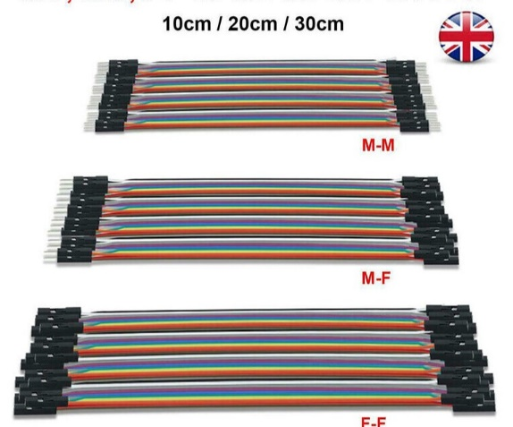

**6. Brown & Black Dupont wires**

**Note.** If following the wiring diagram colour code (recommended) there are far more Brown and Black colour wires used, than come in a standard mixed-colour pack, so the additional Brown & Black wires are recommended.

[10pcs Breadboard Dupont Cable For Arduino Line 2.54mm Male Female Dupont Jumper Wire 26AWG Cable DIY Electronic 1P Connector - AliExpress](https://www.aliexpress.com/item/1005004062117789.html?spm=a2g0o.order_list.order_list_main.5.187e1802YDQBni)

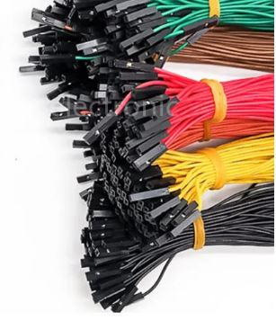

**7. Female pin Header** (Optional)  
There are more 3.3V and 0V connections made to the breakout board than there is space for. All of the wires can be bundled together and connected into a choc-bloc, with one wire then going to the breakout board. A neater solution, but requiring soldering, is to use the female pin header, below. Bend the end leg so it runs along the bottom of the plastic body & solder it to the other legs. One leg can be trimmed to fit neatly into the breakout board and the remaining legs trimmed back to the solder joint.

[10PCS 2.54mm Single Row Female Long pins 11mm Breakaway PCB Board Pin Header socket Connector 1*2/3/4/6/8/10/15Pin For Arduino - AliExpress](https://www.aliexpress.com/item/10000004634458.html?pdp_npi=4%40dis%21GBP%21%EF%BF%A11.09%21%EF%BF%A10.98%21%21%211.35%211.21%21%40211b446117068768470798757ea71f%2120000000015055425%21sh%21UK%212089347981%21&spm=a2g0o.store_pc_allItems_or_groupList.new_all_items_2007550682924.10000004634458)

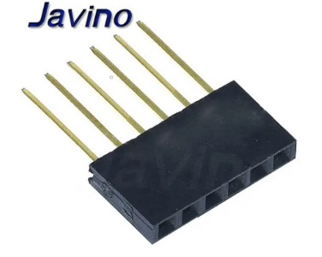

**8. TFT display.**  
  
**4.0 inch SPI module 3.95 inch ILI9488 14 pin TFT LCD display scree Resistance touch panel PCB adapter base board 2.54 mm spacing** (sic)  
  
Board size is 108.04 X 61.74

Note:- there are many similar modules but they have different driver chips (ILI9488), the Develop Timer only works with this specific module. Please ensure you correctly order the module. The Aliexpress web sites often list similar but different modules & sometimes just the bare screen. The 4.0” module does not have the 5V regulator populated on the board (circled).

[4.0 inch SPI module 3.95 inch ILI9488 14 pin TFT LCD display scree Resistance touch panel PCB adapter base board 2.54 mm spacing - AliExpress](https://www.aliexpress.com/item/1005003033828159.html?spm=a2g0o.order_list.order_list_main.120.e3f31802EBPurI)

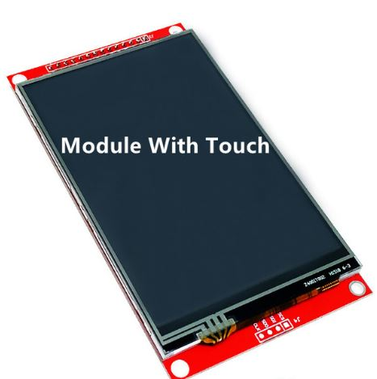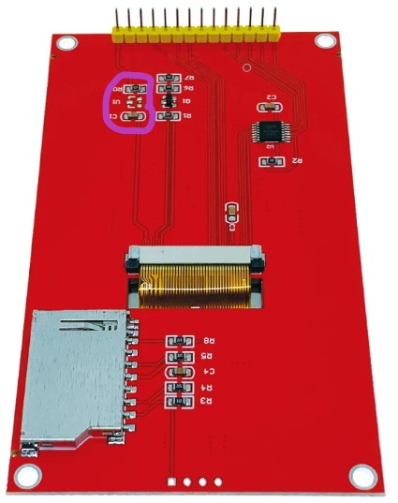

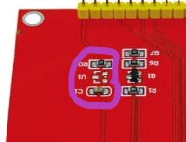 Note:- regulator (U1, written upside down) is not populated on this board.

**9. Rotary Encoder.**  
Ensure you purchase the one with blue pcb as shown below.

[With Switch Rotary Encoder Module for Arduino Brick Sensor Development Round Audio Rotating Potentiometer Knob Cap EC11 - AliExpress](https://www.aliexpress.com/item/1005001696915804.html?pdp_npi=4%40dis%21GBP%21%EF%BF%A11.03%21%EF%BF%A10.75%21%21%211.28%210.93%21%40211b446117068767508306553ea71f%2112000017196951563%21sh%21UK%212089347981%21&spm=a2g0o.store_pc_allItems_or_groupList.new_all_items_2007550682924.1005001696915804)

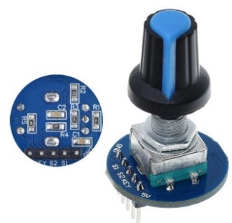

**10. Piezo Sounder.** (optional)

The SFM-27 has an intermittent sound, rather than a constant tone. Audibly warns when next user operation is required (agitation, pour out dev)

[2PCS SFM-27 Buzzer 95DB Active Buzzer High-decibel 3-24V 12V Electronic Buzzers Beep Alarm Intermittent, For Arduino - AliExpress](https://www.aliexpress.com/item/1005002086074761.html?spm=a2g0o.cart.0.0.5e5e38daTaoXBm&mp=1)

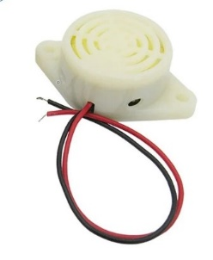

**11. Project Box.** (optional)  
There are all sorts of shapes & sizes of project boxes. The 158 x 90 x 60 is a good siz  
  
[Black Box Outdoor Waterproof Case Plastic Box Electronic Project Case Instrument Waterproof Junction Box Housing - AliExpress](https://www.aliexpress.com/item/1005005622148025.html?spm=a2g0o.productlist.main.15.7e095ac2OMege9&algo_pvid=7bc17347-b46a-4ab9-9953-a2b136f391be&algo_exp_id=7bc17347-b46a-4ab9-9953-a2b136f391be-7&pdp_npi=4%40dis%21GBP%216.38%211.92%21%21%2156.74%2117.02%21%40211b615317070753501476684e2c1f%2112000033783629384%21sea%21UK%212089347981%21&curPageLogUid=Bp5OnsosbjYw&utparam-url=scene%3Asearch%7Cquery_from%3A)

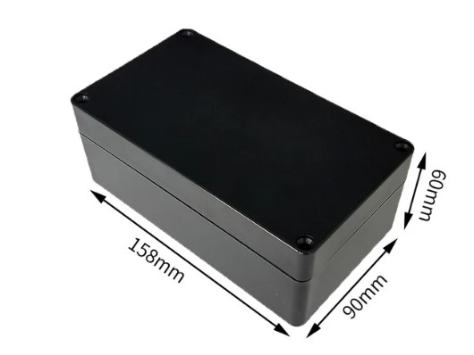

**12. Li-Po Battery** **(Optional, only for use with Lolin D32 board)** With JST PH2.0 connector.  
The prototype was built using the 1000mAh battery. A 2000mAh battery should also work ok.

[523450/503450 1000mAh 3.7V Polymer Lithium Rechargeable Battery Li-ion Battery JST PH2.0 2pin For GPS Smart Phone DVD MP5 - AliExpress](https://www.aliexpress.com/item/1005003198563309.html?spm=a2g0o.order_list.order_list_main.167.76fc1802hCaWQf)

[100% real capacity 3.7V 103450 2000mAh Rechargeable Polymer Lithium Battery, for Cameras, GPS, Bluetooth Speakers，PS4 controller - AliExpress](https://www.aliexpress.com/item/1005004204694483.html?pdp_npi=4%40dis%21GBP%21%EF%BF%A16.06%21%EF%BF%A14.85%21%21%217.46%215.97%21%40211b618e17067900799345178e05af%2112000029430440779%21sh%21UK%212089347981%21&spm=a2g0o.store_pc_allItems_or_groupList.new_all_items_2007586705671.1005004204694483)

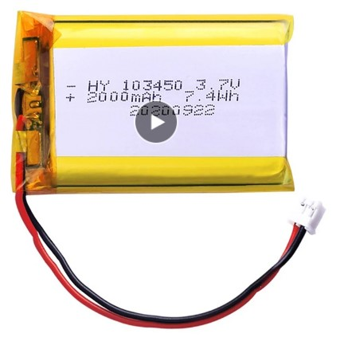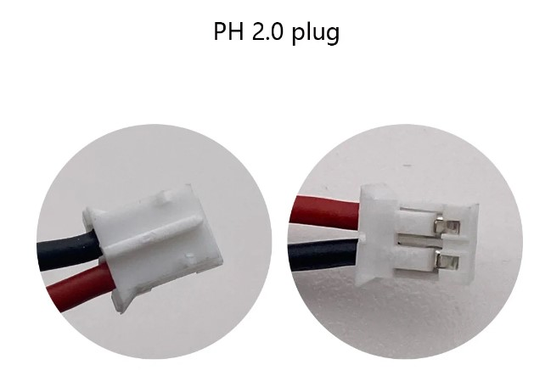

**Red & Black Pins require removal from plastic housing and swapping round.**

**Caution –** There is no standard for the polarity of the battery connector. Check and double check the red & black wires are the correct way round on the battery connector, to match the Lolin processor board. If they are not, carefully lift the plastic locking tab on the connector, securing the pin & slide out. Do this for both pins, taking care not to let them touch. Then re-insert the correct way round. **The batteries specified above have the connector pins the wrong way round and will need to be swapped.**

**Optional Parts if Automatic Twiddling is required.**

Cavet Whilst the stepper motor works fine in testing, it has never been connected to a twiddling stick. The user will have to build their own mounting frame to hold the stepper and devise a method of connecting to a twiddling stick to the motor shaft. Using flexible plastic tube should work.

**a. Stepper Motor.**

Ensure the version with XH line is selected. This will then fit the driver breakout board.

[3D Printer Parts Nema17 17HS4023 for Titan Extruder 4-lead Nema 17 22mm 42 Motor 0.7A 12V 14N.for 3D Printer Motor - AliExpress](https://www.aliexpress.com/item/1005004963609855.html?spm=a2g0o.order_list.order_list_main.78.21ef1802nm9Om5)

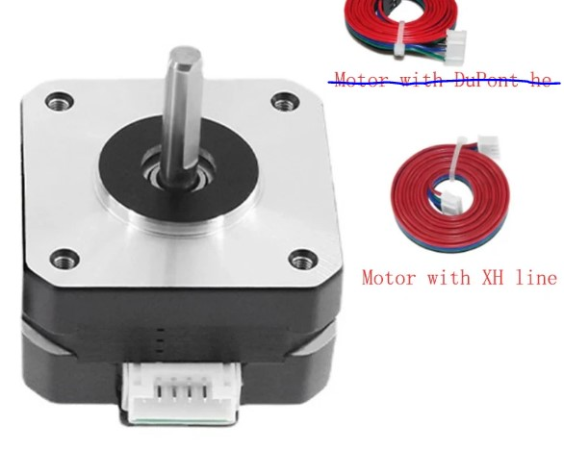

**b. Stepper Motor Driver Board.**  
The version 2 board has the adjusting potentiometer mounted on the top (can be seen just in front of the blue heatsink) making it much easier to adjust than the earlier version.

[TMC2208 TMC2209 ATD5833 V2.0 With Heat Sink Stepper Motor Driver StepStick 3d Printer Parts 2.5A 256 Subdivision Silent Printing (aliexpress.com)](https://www.aliexpress.com/item/1005004862737922.html?spm=a2g0o.cart.0.0.bf1a38daaEBcBB&mp=1)

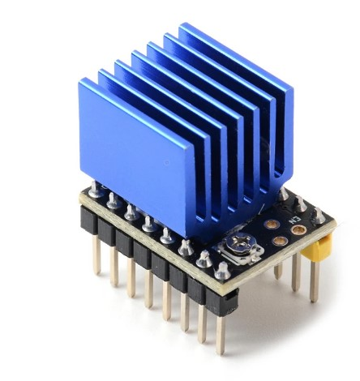

**c. Stepper Motor Breakout Board.**

[42 Stepper Motor Driver Expansion Board DRV8825 A4988 3D Printer Control Shield Module For Arduino 3 Ramps1.4 DIY Kit (aliexpress.com)](https://www.aliexpress.com/item/1005002915948304.html?spm=a2g0o.detail.pcDetailTopMoreOtherSeller.1.7d27SQrdSQrdAd&gps-id=pcDetailTopMoreOtherSeller&scm=1007.40050.354490.0&scm_id=1007.40050.354490.0&scm-url=1007.40050.354490.0&pvid=9d925a7f-cc09-44ee-aa5b-791baa127af2&_t=gps-id:pcDetailTopMoreOtherSeller,scm-url:1007.40050.354490.0,pvid:9d925a7f-cc09-44ee-aa5b-791baa127af2,tpp_buckets:668%232846%238115%232000&pdp_npi=4%40dis%21GBP%211.24%210.80%21%21%211.54%210.99%21%402103853f17068759991957669e1792%2112000022769978764%21rec%21UK%212089347981%21&utparam-url=scene%3ApcDetailTopMoreOtherSeller%7Cquery_from%3A)

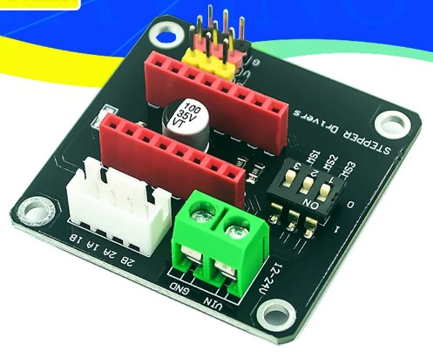

**d. 12 Volt Power Supply.**

A 12V 2A power supply is required to run the stepper motor. A socket could be mounted on the project box, for a neat connection, or use an adaptor (circled), or just cut the connector off & connect directly to the stepper board.  
Note- Only the stepper uses 12V. The processor board still requires connection to a USB power supply. An alternate is to use a buck converter to convert 12V to 5V, negating the need for a separate USB power supply.

[AC DC 12v 1A 2A 3A 2000ma 3000MA adapter power supply EU UK AU US PLUG 5.5*2.5mm wall charger for DC male female led strip light (aliexpress.com)](https://www.aliexpress.com/item/1005001731366424.html?spm=a2g0o.productlist.main.1.500f6b32QiCyro&algo_pvid=004acd70-9d89-4d2b-b7c9-ec0a6010fa74&algo_exp_id=004acd70-9d89-4d2b-b7c9-ec0a6010fa74-0&pdp_npi=4%40dis%21GBP%213.29%212.30%21%21%214.05%212.83%21%402103888a17067916098586464e0cb0%2112000017377597070%21sea%21UK%212089347981%21&curPageLogUid=f1uDLqxuenoS&utparam-url=scene%3Asearch%7Cquery_from%3A)

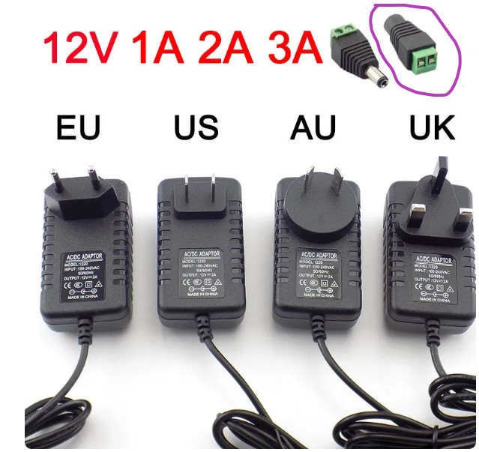

**e. DC Power Jack.** (Optional)

This will allow a socket to be fitted to the project box, for a neat looking solution.

[5/10Pcs 5A 30V For DC Power Supply Jack Socket Female Panel Mount Connector 5.5mm 2.1mm Plug Adapter 2 Terminal Types 5.5x2.1 - AliExpress](https://www.aliexpress.com/item/1005004637388048.html?spm=a2g0o.order_list.order_list_main.114.44f51802aZgZHw)

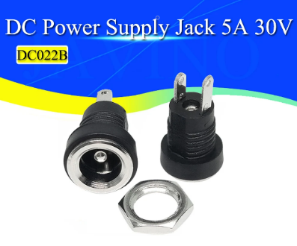

**f. 12 Volt to 5 Volt buck converter.** (Optional)

This will allow a single 12Volt connection to the project, to power both the teepr motor & processor board.

[DC-DC 24V/12V To 5V 5A Step Down Power Supply Buck Converter Replace LM2596S Adjustable USB Step-down Charging Module For Phone - AliExpress](https://www.aliexpress.com/item/32785352477.html?spm=a2g0o.productlist.main.17.4c127c16cq7IFB&algo_pvid=c9d62b18-e4c0-4816-8320-a416ecd5b7b0&algo_exp_id=c9d62b18-e4c0-4816-8320-a416ecd5b7b0-8&pdp_npi=4%40dis%21GBP%211.59%211.43%21%21%211.97%211.77%21%40211b801617068749612433242ec173%2163270023279%21sea%21UK%212089347981%21&curPageLogUid=F6A1cdfWtHPI&utparam-url=scene%3Asearch%7Cquery_from%3A)

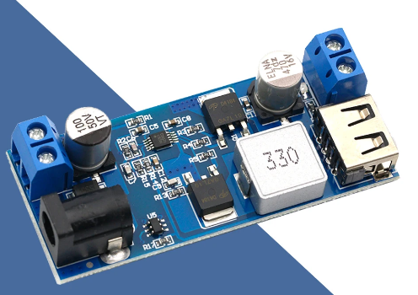

**g. Self Locking switch.** (Optional)

Fit in-line with the stepper motor enable pin, to make an emergency stop button for the stepper motor. Select the Latching, Red option.

[2PCS 12MM Mini 2pin Dome Push Button Switch OFF-ON Momentary Latching Waterproof Plastic Motorcycle (aliexpress.com)](https://www.aliexpress.com/item/1005003020720620.html?spm=a2g0o.productlist.main.3.518bbecd4bKY04&algo_pvid=fab7fcb5-3980-46bc-ad4d-6289abae1229&algo_exp_id=fab7fcb5-3980-46bc-ad4d-6289abae1229-1&pdp_npi=4%40dis%21GBP%210.66%210.66%21%21%210.82%210.82%21%40211b600a17070826680158916e9843%2112000023277510839%21sea%21UK%212089347981%21&curPageLogUid=87mZqLAW7gQ7&utparam-url=scene%3Asearch%7Cquery_from%3A)

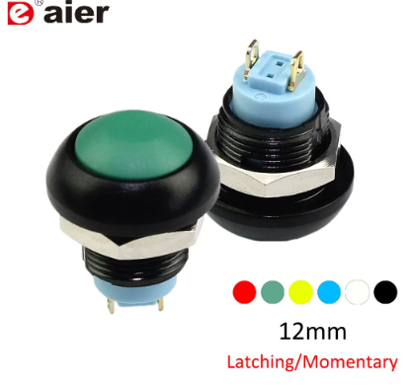

The design of the auto-twiddler is up to the imagination of the builder. A universal joint (5mm) is required to connect the motor to a shaft, which in turn will connect to a rod and then the twiddling stick.

The assembly must then be held in a frame above the developing tank, to engage with the spiral. The frame could be built the same width as the water bath, so it sit just outside, which will also ensure it is the spiral, not the frame, which turns.

[2/3/3.17/4/5/6/6.35/8/10mm Boat Car Shaft Coupler Motor Connector Metal Universal Joint Coupling - AliExpress](https://www.aliexpress.com/item/4000194793728.html?spm=a2g0o.productlist.main.5.76317c86UDU0DY&algo_pvid=a0a1fa0f-dfb3-4a13-8b66-0e8f5cb4fdbb&algo_exp_id=a0a1fa0f-dfb3-4a13-8b66-0e8f5cb4fdbb-2&pdp_npi=4%40dis%21GBP%210.83%210.83%21%21%211.02%211.02%21%40211b600417071363162276946ebdb8%2110000000732905345%21sea%21UK%212089347981%21&curPageLogUid=BhaB6rhZFa2B&utparam-url=scene%3Asearch%7Cquery_from%3A)